Temenos T24™

Business Solution Design Document (BSDD)
Tamweel Aloula
Financial Accounting & Reporting


Document History

Date | Version | Author | Section(s) Amended
28/02/2025 | 1.0 | Mohsin Raza | First draft
Document Sign Off

Date | Version | Name | Company / Position

Table of Contents
Contents
1 Purpose 4
2 Glossary 4
3 Overview / Scope of Functional Requirements 5
3.1 Requirements Overview 5
3.1.1 Overview of Financial Accounting & Reporting 5
3.2 Summary of Requirements 5
4 Detailed Description of Functional Requirements. 6
4.1 Consol Variables - Asset & Liabilities | WS08-01-01 6
4.2 Product Type | WS08-01-02 6
4.3 Consol Variables – Profit & Loss | WS08-02-01 7
4.4 Reporting Heads | WS08-09-01 7
4.5 Journal Posting – Bulk Upload | WS08-11-01 9
4.6 Journal Posting – Multi Debit & Multi Credit | WS08-11-02 10
4.7 Journal Posting – Multi Debit & Multi Credit – File Upload | WS08-11-03 10
4.8 Journal Posting – Posting Restriction | WS08-11-04 11
4.9 Journal Posting – Six Eye Principle | WS08-11-05 11
4.10 DAO | WS08-23-01 11
4.11 Financial Enquiries | WS08-26-01 12
4.12 Segregated User Menu | WS08-27-01 12
4.13 Value Dated Accounting & Transaction Journal | WS08-28-01 13
5 Reference Documents. 14

Purpose
The purpose of this document is to document Tamweel Aloula’s business requirements for Financial Accounting and Reporting Module.

The scope of the document is limited to collecting the requirements from the client’s representatives. We do not recommend that any designs are included in this document.

Glossary

Term | Description
BRD | Business requirements document
COB | Close of business process
TA | Tamweel Aloula

Overview / Scope of Functional Requirements

Requirements Overview

Overview of Financial Accounting & Reporting

The Transact Financial Accounting and Reporting module will help you understand how core tables such as Category, Country, Industry, and Sector are linked, identify various types of accounting entries, and explore the different date types associated with these entries. It also covers the conditions for consolidating accounting entries and highlights the key differences between the traditional General Ledger and T24 Transact's virtual GL.

Summary of Requirements

GAP Reference | Requirement Title | Gap Type
WS08-01-01 | Consol Variables for Asset & Liability | Configuration
WS08-01-02 | Product Type | Customization
WS08-02-01 | Consol Variables for Profit & Loss | Configuration
WS08-09-01 | Reporting Heads | Configuration
WS08-11-01 | Bulk Upload Functionality – FT | Configuration
WS08-11-02 | Multi Debit & Multi Credit Functionality | Customization
WS08-11-03 | Multi Debit & Multi Credit Functionality – Bulk Upload | Customization
WS08-11-04 | Posting Restriction | Configuration
WS08-11-05 | 6 Eye Principle | Configuration
WS08-23-01 | DAO | Customization
WS08-26-01 | Financial Enquiries | Configuration
WS08-27-01 | User Menu | Configuration
WS08-28-01 | Account Parameter | Configuration

Detailed Description of Functional Requirements.

Consol Variables - Asset & Liabilities | WS08-01-01

Following are the Consolidate.Cond variables for Asset and Liability has been agreed:
- CATEGORY
- SEGMENT
- SECTOR
- RESIDENCE
- TIME
- INDUSTRY
- DAO
- EMPLOYMENT STATUS
- EMPLOYMENT TYPE
- REGION
- PRODUCT TYPE

The above-mentioned variables will be defined in ASSET&LIABILITY record of CONSOLIDATE.COND.

Product Type | WS08-01-02

To meet TA’s requirement, the Product Type—defined as the purpose of the financing, such as "Healthcare" in the case of Murabaha for Healthcare—needs to be introduced as one of the consol variable. To facilitate this, a local field named L.SUB.PRODUCT.TYPE will be created in the SMB.DEAL.DETAIL and IS.CONTRACT table. This field will initially capture the product type data directly from the digital platform at the time of financing initiation.
Additionally, the same field L.SUB.PRODUCT.TYPE will be created in the AA.PRD.DES.ACCOUNT. During the creation of a financing contract, the product type will be automatically populated in the AA.PRD.DES.ACCOUNT table based on the reference record stored in the IS.CONTRACT. Once the financing contract is created, the captured product type will also be transferred and stored in the ACCOUNT table.
To enable mapping between the descriptive product type and a system-recognized code, another field called L.PRODUCT.TYPE.CODE will be added to the ACCOUNT table. A routine will be associated with this field, which will retrieve the relevant numeric code for the product type. This routine will access the EB.SMB.H.GENERIC.PARAMS table, locate the record PRODUCT.TYPE.CODE, and extract the numeric code corresponding to the value found in L.SUB.PRODUCT.TYPE—for instance, the code defined for "Healthcare." The retrieved code will then be stored in the L.PRODUCT.TYPE.CODE field in the ACCOUNT table.
Once the numeric product type code is populated, it will become part of the consolidation key used for reporting purpose.
Below is the reference screenshot of the coding table
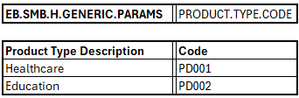

Consol Variables – Profit & Loss | WS08-02-01

Following are the Consolidate.Cond variables for Profit & Loss has been agreed:
- PLCATEGORY
- PLPRODUCT
- PLSEGMENT
- PLSECTOR
- PLRESIDENCE
- PLTIME
- PLINDUSTRY
- PLDEPARTMENT
- PLEMPLOYMENT STATUS
- PLEMPLOYMENT TYPE
- PLREGION
- PLPRODUCT TYPE

The above-mentioned variables will be defined in PROFIT&LOSS record of CONSOLIDATE.COND

Reporting Heads | WS08-09-01

TA requires the "TABS" & "TAPL" report to be configured in Transact as a Closing Type Report, Movement Type Report and YTD report for profit and loss. This requirement will be achieved by creating a records "TABS" & “TAPL” in the RE.STAT.REPORT.HEAD table. Furthermore, TA requires multiple extensions that allows the presentation of the “TABS” & “TAPL” in different column types. This will be accomplished by utilizing the COLUMN.TYPE field and selecting different column options from the drop-down menu. The following screenshot illustrates the Closing Type report.
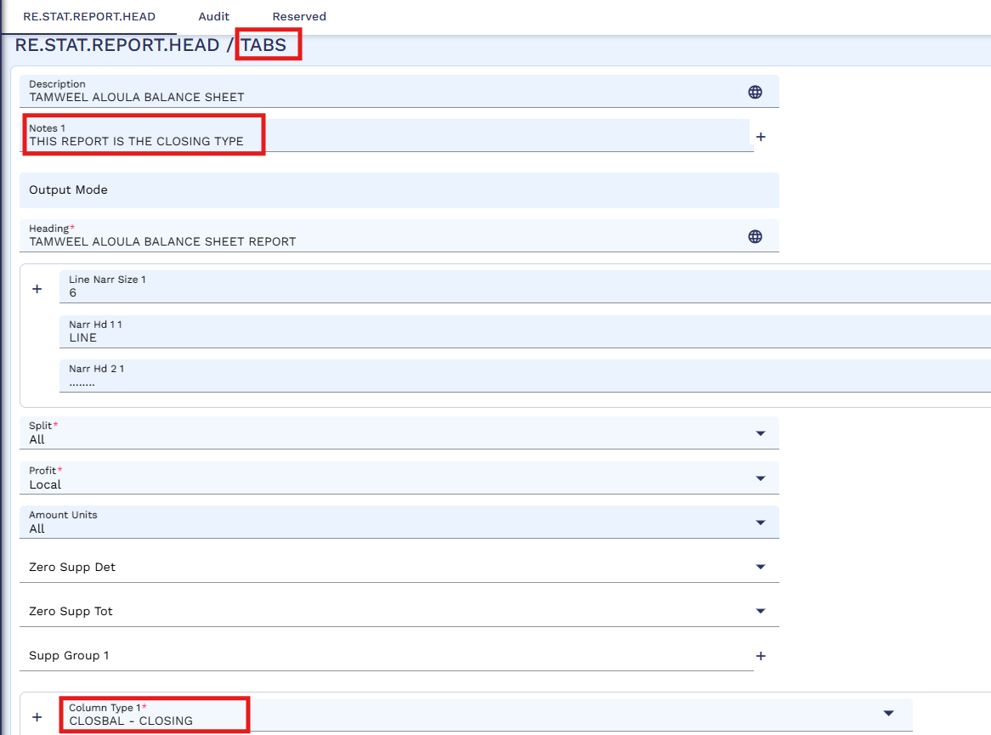

Multiple extensions can be created through the RE.STAT.REPORT.HEAD, with the record ID distinguishing each report. For a movement type report, the record ID will be "TABS.MVMT" & “TAPL.MVMT” While the overall structure of the GL & PL will remain the same, this extension will only include the movement type columns, as specified by TA. The following screenshots illustrate movement type reports configuration.

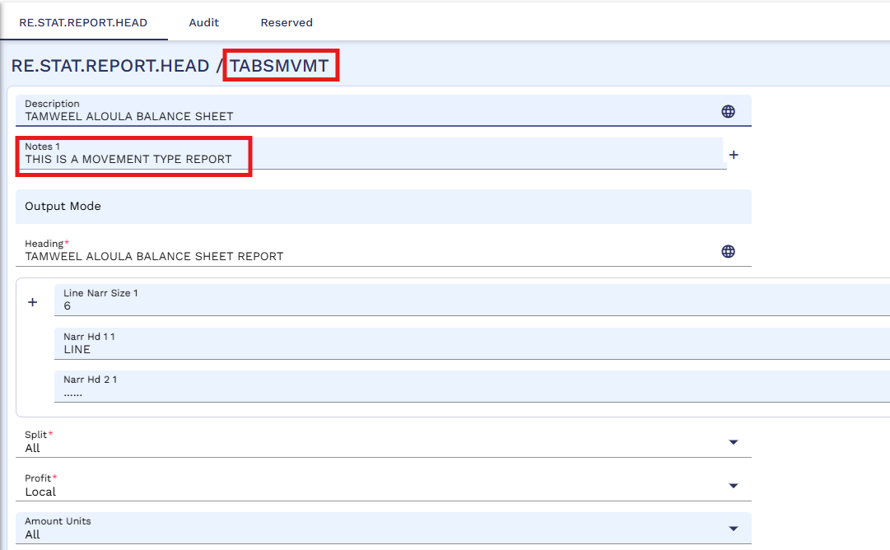

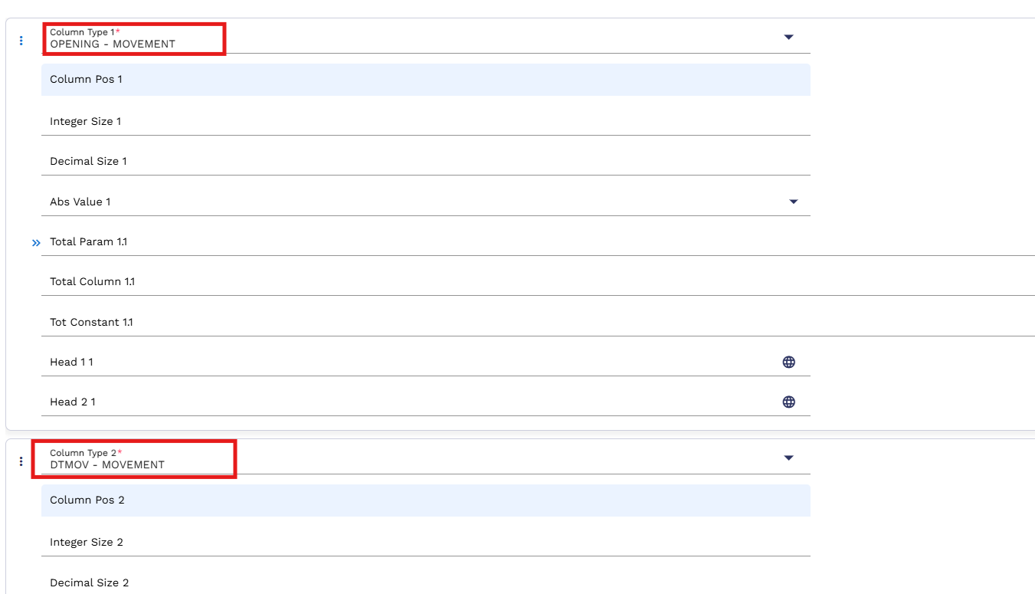

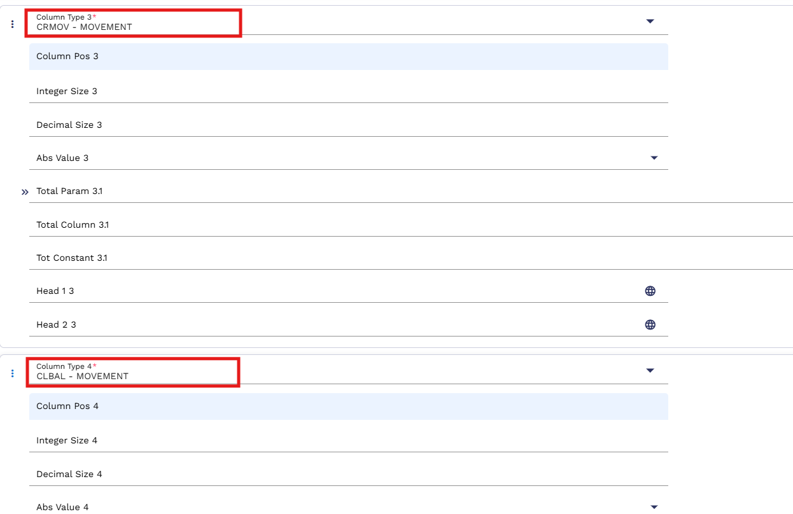

Similarly, a year to date profit & loss report will be created through the RE.STAT.REPORT.HEAD, with the record ID differentiating this report. For the year to day profit & loss report, the record ID will be "TAPL.YTD". In this extension, the structure of the profit & loss report will remain the same, but the report will present the current month and year to date balances in separate columns, as required by TA. This can be achieved by setting two columns “CM - CLOSING” & “YTD – CLOSING” in COLUMN.TYPE field in RE.STAT.REPORT.HEAD. Following screenshot illustrates the YTD profit and loss report.

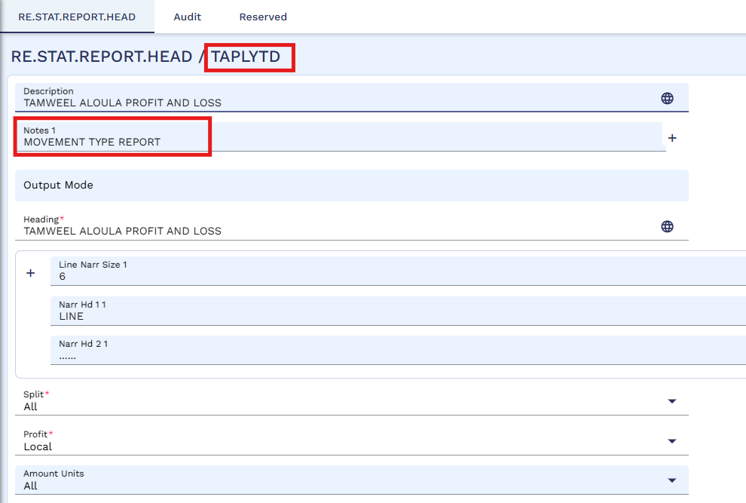

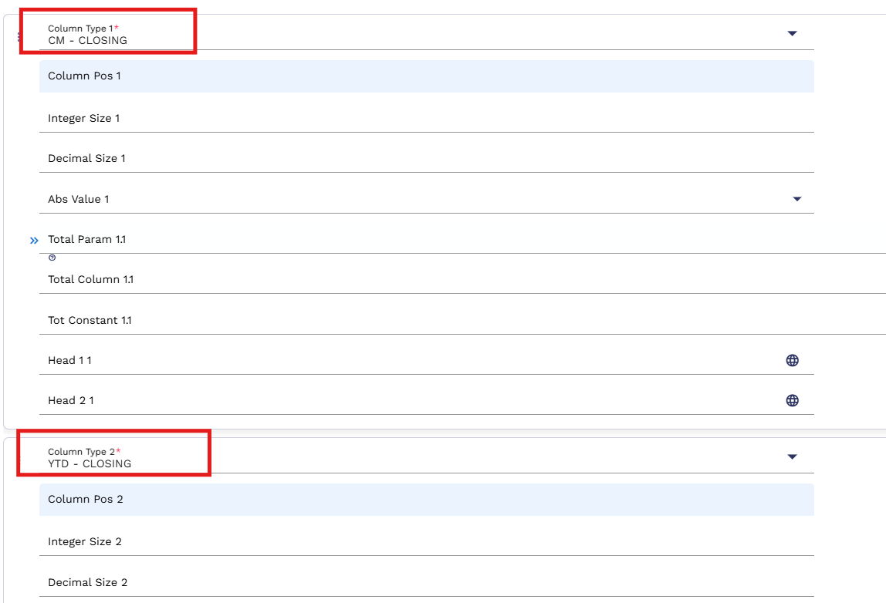

Journal Posting – Bulk Upload | WS08-11-01
In Transact, the design should feature a dedicated version for FT adjustment entries. This version must support bulk file upload functionality, enabling users to upload a file with multiple adjusting entries at once, instead of processing individual FT(s) separately. Furthermore, the version should comply with the "four-eye principle," ensuring that it is exclusively accessible and managed by designated finance users.
A new version of FUNDS.TRANSFER,TA.FU will be created with the field NO.OF.AUTH set to 1, as outlined in GAP# WS08-11-05. This version will be used to configure the Bulk Funds Transfer (FT) Upload Utility through EB.FILE.UPLOAD. As part of the setup, an EB.FILE.UPLOAD.TYPE record will be created using this version to define the format and fields required for uploading bulk FT entries, particularly for manual adjustment postings. The process begins with the user uploading a file containing adjustment entries. After uploading, the file is submitted for authorization. An authorized user will then review the contents of the file and either authorize or delete the uploaded FT records based on their assessment. To ensure proper access control, this version will be linked to the Finance Menu, making the functionality accessible only to designated users with the appropriate permissions.

Journal Posting – Multi Debit & Multi Credit | WS08-11-02

The Transact system is expected to incorporate functionality for multi-debit and multi-credit transactions, ensuring compliance with the four-eye principle. This functionality is essential for business units, particularly in Finance, that handle a significant volume of such transactions on a regular basis.

Multi-Debit refers to situations where multiple debit transactions are applied against a single credit, while multi-credit refers to the reverse scenario, where multiple credit transactions are applied to a single debit. To support these processes, the system will enable users to post, retrieve, and view multi-debit and multi-credit transactions efficiently. This will be available through a unified entry posting form, each associated with a unique Record ID, generated during the transaction. The Record ID allows users to easily access the results of a specific transaction or a set of related transactions.

The functionality required in this gap will be built on core FUNDS TRANSFER (FT) module in Transact, where for every single record one debit and one credit transaction is applicable. To cater Multi Debit Multi Credit requirement, a suspense internal account will be used to balance each FT record. This suspense internal account will be defined in a parameter. Following will be taking place:

- DAO/ Department field currently not mandatory for PL and will be made mandatory for input for PL category line only. For internal accounts and customer accounts DAO/ Department field will be auto populated with their DAO.
- Exchange Rate field will be open for input in case Currency is other than Local Currency.
- In case of Foreign Currency transactions, Local Currency and Foreign Currency Amount fields for PL category line (Debit or Credit) will be auto populated from the other side of the transaction on validation of the record. Pl category line will be considered in Local Currency. Auto recon field will be added.
- Transaction type will be separately identified.
- The sum of debits should be balanced against the sum of credits without considering internal suspense account.
Following is the mock screenshot for reference.

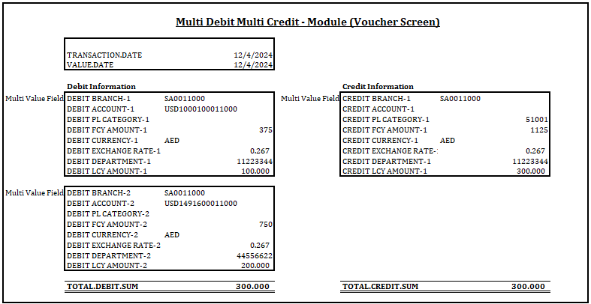

Journal Posting – Multi Debit & Multi Credit – File Upload | WS08-11-03
In Transact, TA requires that the multi-debit and multi-credit functionality be available through the bulk upload feature. A specific version will be created for configuring the Bulk Upload Utility via EB.FILE.UPLOAD. Below is an illustration of the EB.FILE.UPLOAD configuration.
The EB.FILE.UPLOAD.TYPE record will be used to capture user-submitted bulk MDMC files for entries, including all the relevant fields.
In the first step, the user will upload a file containing accounting entries. After the file is uploaded, the user will submit it for authorization. The authorizer can then review the bulk upload and decide whether to authorize or delete the uploaded file.
A sample screenshot for journal posting is provided below:

Journal Posting – Posting Restriction | WS08-11-04
The Transact system should be designed to allow TA to restrict the posting of manual entries. To enforce this, the system must include functionality that generates a restriction error when a user attempts to post an entry. Posting rights will be granted exclusively to designated finance users.
To meet the requirement, input restrictions will be applied to a specific group of users for the FUNDS.TRANSFER and MULTI DEBIT & MULTI CREDIT application. These restrictions will be enforced using the APPLICATION and FUNCTION fields in the USER table. As a result, users with input restrictions will not be able to process manual transactions. Only authorized users from the finance department will be granted the necessary INPUT function to post manual entries.
Note: This solution assumes that only authorized users are allowed to post manual transactions. If the requirement changes to include posting restrictions based on specific PL and Internal Categories, the solution may be revised accordingly.

Journal Posting – Six Eye Principle | WS08-11-05
TA also requires the implementation of the "six-eye principle" for posting manual transactions. Therefore, the system should be designed to include a mechanism that incorporates a maker, checker, and authorizer workflow.
To meet this requirement, a new version of FUNDS.TRANSFER, labeled FUNDS.TRANSFER,TA.TRANS, will be created. In this version, the field NO.OF.AUTH will be set to 2.
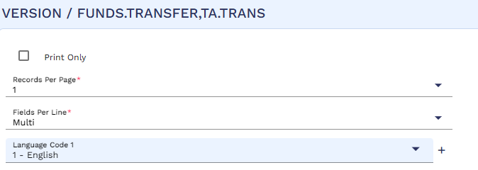
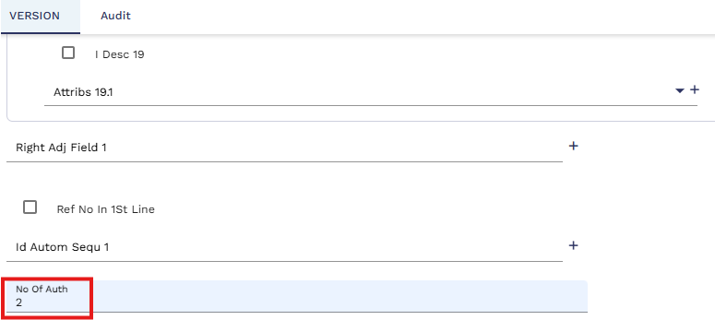

DAO | WS08-23-01

To fulfill TA's requirement of tagging a profit center to each financing deal, we will assign a profit center based on the Segment and Product combination. For instance, if Murabaha financing is provided for the Retail Segment, the profit center will be "Retail-Murabaha."

To implement this, we will use the product category in the Transact system, as different segments (Retail, Corporate, and SME) will have different product categories for Murabaha financing. Once the financing application is processed in Transact, a record will be created in the SMB.DEAL.DETAIL table. A local field, L.PROFIT.CENTER, will be introduced within this table.

A routine will be associated with this field to perform the following steps:

- Check the product description in the SMB.PRODUCT field in SMB.DEAL.DETAIL table.

- Cross-reference the product description with the category code in the AA.PRD.DES.ACCOUNT conditions.

- Once the category code is identified, the routine will search the EB.SMB.H.GENERIC.PARAMS table to locate the corresponding PROFIT.CENTRE record.

- The routine will extract the numeric PROFIT.CENTRE code associated with the found category code (e.g., the PROFIT.CENTRE code for "3701 (TAWARUK)").

- The retrieved PROFIT.CENTRE code will then be stored in the L.PROFIT.CENTER field of the SMB.DEAL.DETAIL table.

After storing the profit center number in SMB.DEAL.DETAIL, it will be pushed to all reference records related to the request in the L.PROFIT.CENTER (new field to be created) field of the IS.CONTRACT table. Additionally, the same profit center number will be pushed to the ACCOUNT.OFFICER field in both the AA.PRD.DES.ACCOUNT and ACCOUNT tables once the financing deal is created.

Below is the reference screenshot of the coding table.

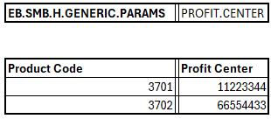

NOTE: TA to provide the profit center numbers, so the same can be configured in Transact.

Financial Enquiries | WS08-26-01
TA Requires Following Enquiries:
- Unauthorized Transactions
- Transaction Entries
- Account Statement Enquiry
- Category Balance Enquiry
- Forward Entries Enquiry
- End of Day reports Enquiry
- Journal Summary
- Contract Balances Enquiry
- Line Content Enquiry

These enquiries are available by core. All of these will be attached in the Finance menu.

Segregated User Menu | WS08-27-01

TA requires segregated user menus for input and authorization to maintain checks and balances. One user menu will be used for inputting a transaction, while other user menu will handle the authorization, implementing the maker and checker methodology.

This requirement will be addressed through the use of the applications HELPTEXT.MENU and HELPTEXT.MAINMENU, which will serve to create two distinct menus. These menus will be assigned to the respective users based on their roles. Users responsible for initiating transactions, creating lines, setting up internal accounts, and defining categories will be assigned the input menu. Meanwhile, users tasked with reviewing and authorizing the aforementioned actions will be granted access to the authorization menu.

Value Dated Accounting & Transaction Journal | WS08-28-01
TA requires a value-dated accounting system, where transactions with a future value date are posted as off-balance-sheet items until the specified date arrives and the customer account balances are affected on the value date only. Additionally, TA requires a report that displays daily transactions initiated across all modules in the system.
To address these requirements, the TXN.JOURNAL report will be enabled, which will provide detailed transactional information for all applications. Both of these needs will be addressed through the necessary configurations in the ACCOUNT.PARAMETER table:
- Setting VALUE.DATED.ACCTING to "Y" will enable value-dated accounting.
- Setting BYPASS.TXN.JOURNAL to "N" will enable the generation of the TXN.JOURNAL report.

Reference Documents.

